Retrieval-Augmented Generation (RAG)

Why Do We Need RAG?
Language Models (LLMs) are powerful, but they come with certain limitations:
- They are trained on static datasets, meaning they do not have access to real-time or updated information.
- They cannot access private or proprietary data unless explicitly provided during training.
- Fine-tuning models for every new dataset is expensive, time-consuming, and not scalable.
To overcome these limitations, Retrieval-Augmented Generation (RAG) is introduced.
RAG enables an existing LLM to:
- Answer questions based on external documents it was never trained on
- Provide up-to-date and context-specific information
- Maintain data privacy, since sensitive data remains outside the model and is retrieved only when needed
In simple terms, RAG allows an LLM to become knowledge-aware without retraining.

What is RAG?
Retrieval-Augmented Generation (RAG) is an architectural pattern that combines information retrieval with language generation.
It allows foundation models to generate accurate, context-aware, and grounded responses by retrieving relevant information from external knowledge sources and using it as context during generation.

Benefits of RAG
- Access to up-to-date information
- Improved accuracy and factual grounding
- No need for frequent model retraining
- Enhanced data privacy (data stays external)
- Scalable for large document collections

Example
Consider a company with internal policy documents.
- A user asks: “What is the leave policy for remote employees?”
- The LLM alone may not know this.
- With RAG:
  - Relevant policy documents are retrieved
  - Passed to the model as context
  - The model generates an accurate, company-specific answer
Retrieval-Augmented Generation (RAG) enhances the capabilities of LLMs by integrating external knowledge retrieval into the generation process. It enables models to produce accurate, context-aware, and up-to-date responses while maintaining scalability and data privacy. This makes RAG a foundational pattern for building real-world GenAI and agentic AI applications.

How RAG Works
RAG operates in two major stages:

1. Build Time (Data Preparation & Embedding)
At this stage, the system prepares the knowledge base.
Steps involved:
Data Collection:
Gather client-specific data such as documents, manuals, FAQs, or tickets.
Preprocessing:
Convert formats (PDF → text)
Clean and structure content
Add metadata (source, tags, etc.)
Expand abbreviations if needed
Chunking:
Large documents are split into smaller, meaningful pieces (chunks).
Embedding Generation:
Each chunk is converted into a vector representation using an embedding model.
Storage in Vector Database:
These vectors are stored in a vector database such as:
FAISS
Milvus
Chroma
This completes the knowledge base setup.

2. Runtime (Query, Retrieval & Generation)
This stage happens when a user interacts with the system.
Step-by-step flow:
User Query
The user submits a question in the application.
Query Embedding
The query is converted into a vector using the same embedding model.
Semantic Search (Retrieval)
The system searches the vector database to find the top K most relevant chunks.
Context Augmentation
Retrieved chunks are combined with the user query to form a prompt.
LLM Processing
The prompt is sent to the LLM.
Response Generation
The LLM generates a response using both:
Its internal knowledge
Retrieved external context
Output
The final response is presented to the user.

Indexing in Retrieval-Augmented Generation (RAG)

What is Indexing?
Indexing is the process of transforming raw, unstructured data into a structured and searchable format so that it can be efficiently retrieved during query time.
In the context of RAG, indexing involves:
- Processing documents
- Converting them into embeddings (vector representations)
- Storing them in a vector database
In simple terms, indexing prepares your data so that the system can quickly find relevant information later.
With indexing:
- Data becomes searchable using meaning (semantic search)
- Retrieval becomes fast and scalable
- Responses become accurate and context-aware
Indexing is a part of the build phase of RAG and happens before runtime interaction.
It ensures that:
- All knowledge is preprocessed
- Stored efficiently
- Ready for retrieval when a user query arrives

Indexing Workflow
The indexing pipeline typically consists of the following steps:
- Document Loading
- Text Splitting (Chunking)
- Embedding Generation
- Vector Storage
- Retriever Configuration

Indexing Workflow Diagram

Step 1: Document Loading

Definition
A Document Loader is responsible for ingesting raw data from various sources and converting it into a standardized document format.

What Happens in This Step?
- Data is collected from different sources:
  - PDFs
  - Text files
  - Web pages
  - Databases
- The content is extracted and structured into:
  - Text (page_content)
  - Metadata (source, page number, etc.)
In the indexing phase of a RAG pipeline, document loading is the first step where raw data from different file formats is read and converted into a unified text format. This ensures that downstream processes like chunking and embedding can work seamlessly.
--------------------------------------------------
DOCUMENT LOADER IMPLEMENTATION
--------------------------------------------------
import os
import PyPDF2
import docx

# -------------------------------
# File Readers for Different Formats
# -------------------------------

def read_text_file(file_path: str):
"""
Reads content from a plain text (.txt) file.

Args:
file_path (str): Path to the text file
Returns:
str: Entire content of the file as a string
"""
with open(file_path, 'r', encoding='utf-8') as file:
return file.read()

def read_pdf_file(file_path: str):
"""
Extracts text content from a PDF file.
Args:
file_path (str): Path to the PDF file
Returns:
str: Combined text extracted from all pages
"""
text = ""
with open(file_path, 'rb') as file:
pdf_reader = PyPDF2.PdfReader(file)

for page in pdf_reader.pages:
text += page.extract_text() + "\n"

return text

def read_docx_file(file_path: str):
"""
Extracts text content from a DOCX (Word) file.

Args:
file_path (str): Path to the DOCX file

Returns:
str: Combined text from all paragraphs
"""
doc = docx.Document(file_path)

return "\n".join([paragraph.text for paragraph in doc.paragraphs])

# -------------------------------
# Unified Document Loader
# -------------------------------

def read_document(file_path: str):
"""
Reads a document based on its file extension.

Supported formats:
- .txt
- .pdf
- .docx
"""

_, file_extension = os.path.splitext(file_path)
file_extension = file_extension.lower()

if file_extension == '.txt':
return read_text_file(file_path)

elif file_extension == '.pdf':
return read_pdf_file(file_path)

elif file_extension == '.docx':
return read_docx_file(file_path)

else:
raise ValueError(f"Unsupported file format: {file_extension}")

# -------------------------------
# Example Usage
# -------------------------------

file_path = r"E:\\path\\to\\your\\file.pdf"

text = read_document(file_path)

print(text)

Step 2:Text Splitting (Chunking) in RAG
After documents are loaded, the next step in the indexing pipeline is Text Splitting (Chunking).
Chunking is the process of dividing large documents into smaller, manageable pieces (chunks) so that they can be efficiently:
- Embedded
- Stored
- Retrieved
Since embedding models have input limits and work better with focused context, chunking is essential for improving retrieval quality.

Why Chunking is Important
- Prevents token limit issues
- Improves embedding quality
- Enables fine-grained retrieval
- Reduces irrelevant context in responses

Common Chunking Strategies

1. Fixed-Size Chunking
Splits text into chunks of a fixed number of characters or tokens.
- Simple and fast
- May break context in the middle of sentences
Example: Every 500 tokens = 1 chunk
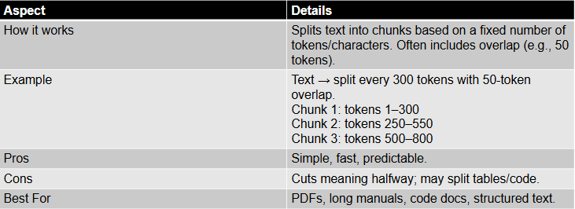

2. Semantic Chunking
Splits text based on meaning and context rather than size.
- Groups semantically related sentences
- Uses embeddings or similarity to decide boundaries
- Better context preservation
- More computationally expensive
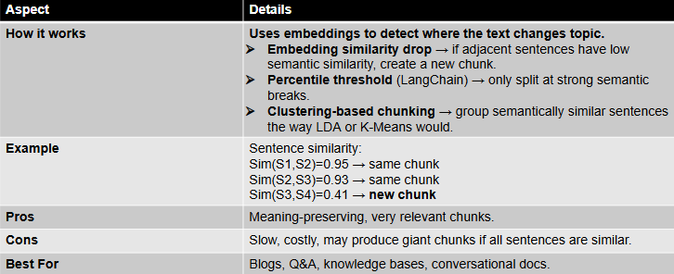

3. Structure-Aware Chunking
Respects the document structure while splitting.
- Uses headings, paragraphs, sections
- Keeps logical units intact
- Ideal for PDFs, reports, documentation
- Depends on well-structured input
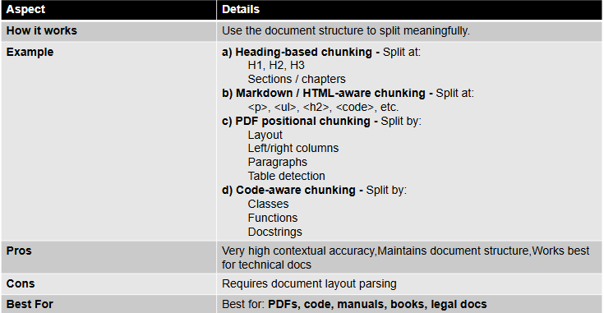

4. Sentence-Level + Grouping
Splits text into sentences and then groups them into chunks.
- Maintains sentence boundaries
- Combines multiple sentences into a chunk
- Balanced approach (clarity + control)
- May still miss deeper semantic grouping
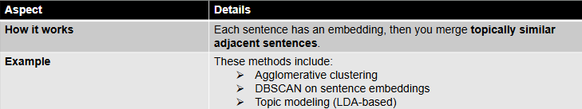

5. Query-Aware Chunking
Chunks are created or selected based on user query relevance.
- Dynamically adapts chunking based on query
- Often used in advanced retrieval systems
- Highly relevant results
- More complex to implement
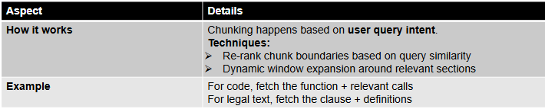

6. Graph-Based Chunking
Represents text as a graph of connected ideas.
- Nodes → concepts or sentences
- Edges → relationships
- Enables retrieval of connected context
- Powerful for complex knowledge systems
- Advanced and resource-intensive
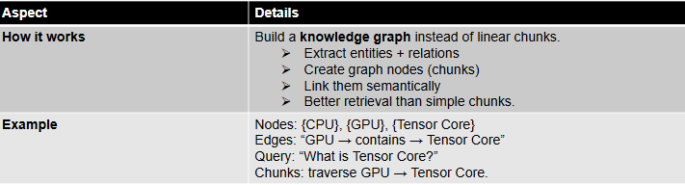
--------------------------------------------------
TEXT SPLITTING (CHUNKING) IMPLEMENTATION
--------------------------------------------------

def split_text(text: str, chunk_size: int = 500):
"""
Splits input text into smaller chunks based on sentence grouping.

Args:
text (str): Input text to be split
chunk_size (int): Maximum size of each chunk (in characters)

Returns:
list: List of text chunks
"""

# Step 1: Normalize text and split into sentences
sentences = text.replace('\n', ' ').split('. ')

chunks = []
current_chunk = []
current_size = 0

# Debug: total number of sentences
print(f"Number of sentences: {len(sentences)}")

# Step 2: Iterate through sentences
for sentence in sentences:
sentence = sentence.strip()

# Skip empty sentences
if not sentence:
continue

# Ensure proper sentence ending
if not sentence.endswith('.'):
sentence += '.'

sentence_size = len(sentence)

# Step 3: Check if adding sentence exceeds chunk size
if current_size + sentence_size > chunk_size and current_chunk:
# Save current chunk
chunks.append(' '.join(current_chunk))

# Start new chunk
current_chunk = [sentence]
current_size = sentence_size
else:
# Add sentence to current chunk
current_chunk.append(sentence)
current_size += sentence_size

# Step 4: Add remaining chunk
if current_chunk:
chunks.append(' '.join(current_chunk))

return chunks

# -------------------------------
# Example Usage
# -------------------------------

chunks = split_text(text)

# Print a sample chunk
print(chunks[2])

Step 3 : Embedding Generation in RAG
After text is split into chunks, the next step in the indexing pipeline is Embedding Generation.
Embedding generation is the process of converting text chunks into numerical vector representations that capture their semantic meaning.

What are Embeddings?
Embeddings are dense numerical vectors that represent text in a high-dimensional space.Instead of storing raw text, we store its meaning in the form of numbers.
- Similar meaning → vectors are close together
- Different meaning → vectors are far apart

Why Embeddings are Important
- Enable semantic search (search by meaning, not keywords)
- Improve retrieval accuracy
- Allow comparison between query and documents
- Form the foundation of vector databases

How Embedding Generation Works
- Each text chunk is passed to an embedding model
- The model converts the chunk into a vector (list of numbers)
- These vectors are stored in a vector database
- During retrieval, user queries are also converted into vectors and compared

Step 4: Storing Embeddings in Vector Databases
After generating embeddings, the next step in the RAG indexing pipeline is to store these embeddings in a vector database along with metadata.
This enables fast and efficient retrieval of relevant information during runtime.

What is a Vector Database?
A vector database is a specialized database designed to store and search high-dimensional vectors (embeddings).
Unlike traditional databases that use exact matching, vector databases perform similarity search based on meaning.

What Gets Stored?
Each entry in a vector database typically contains:
- Embedding (Vector) → Numerical representation of the chunk
- Text (Chunk) → Original text content
- Metadata → Additional information such as:
  - Source file name
  - Page number
  - Document type
  - Tags or categories

Why Store Metadata?
Metadata plays a crucial role in improving retrieval:
- Helps in filtering results (e.g., specific document or topic)
- Provides context for the retrieved chunk
- Enables traceability (knowing where the answer came from)

How It Works
- Each chunk is converted into an embedding
- The embedding is stored in the vector database
- Along with:
  - Original text
  - Metadata
- The database indexes these vectors for fast similarity search
--------------------------------------------------
VECTOR STORE SETUP (CHROMADB)
--------------------------------------------------

import chromadb
from chromadb.utils import embedding_functions

# Step 1: Initialize persistent client (stores data locally)
client = chromadb.PersistentClient(path="./chroma_db")

# Step 2: Define embedding function using Sentence Transformers
embedding_function = embedding_functions.SentenceTransformerEmbeddingFunction(
model_name="all-MiniLM-L6-v2"
)

# Step 3: Create or load collection
collection = client.get_or_create_collection(
name="documents_collection",
embedding_function=embedding_function
)

Step 5: Retriever in RA
After storing embeddings in a vector database, the next step is the Retriever.
A retriever is responsible for fetching the most relevant chunks from the vector database based on a user query.

What is a Retriever?
A retriever is a component that performs semantic search to find text chunks that are most similar in meaning to the user’s query.
It acts as a bridge between:
- User query
- Stored knowledge (embeddings in vector DB)

How Retriever Works
- User enters a query
- Query is converted into an embedding vector
- The retriever compares this vector with stored embeddings
- It selects Top-K most similar chunks
- Returns these chunks as context

What is Top-K?
Top-K refers to the number of most relevant results retrieved.
- K = 3 → top 3 relevant chunks
- K = 5 → top 5 relevant chunks
Choosing K is important:
- Too small → may miss important context
- Too large → may introduce noise

Types of Retrieval

1. Similarity-Based Retrieval
- Uses distance metrics like cosine similarity
- Finds chunks closest in meaning

2. Keyword + Semantic Hybrid
- Combines keyword matching with embeddings
- Improves accuracy in some use cases

3. Metadata Filtering
- Filters results using metadata (e.g., file, topic)
- Improves precision

4. MMR (Maximal Marginal Relevance)
- Reduces redundancy in retrieved chunks
- Ensures diversity in results

Why Retriever is Important
- Ensures only relevant context is sent to LLM
- Improves accuracy of responses
- Reduces hallucination
- Optimizes token usage

Example
User Query:
"What is RAG?"
Retriever Output (Top-3 Chunks):
- Chunk 1: Definition of RAG
- Chunk 2: RAG architecture explanation
- Chunk 3: Benefits of RAG

(Runtime Phase)

Step: 1 Query Processing in RAG
Once the offline indexing pipeline is complete, the system moves to the runtime phase, where it interacts with the user.
The first step in this phase is Query Processing, where the user’s question is prepared for retrieval.

What is Query Processing?
Query processing is the step where a user’s input question is understood, transformed, and prepared so that relevant information can be retrieved from the vector database.
Here the user’s input is transformed into an embedding and used to retrieve relevant information from the vector database. This step ensures that the system understands the intent of the query and provides meaningful context for response generation.

How It Works
- User Query Input
  - The user enters a natural language query
  - Example: “What is RAG?”
- Query Embedding
  - The query is converted into a vector representation using the same embedding model used during indexing
- Semantic Matching
  - The query vector is compared with stored embeddings in the vector database
- Retrieve Relevant Chunks
  - The system fetches Top-K most relevant chunks based on similarity

Example
User Query:
“How does RAG work?”
Process:
- Query → Converted to embedding
- Compared with stored vectors
- Top relevant chunks retrieved

Step 2: Augmentation in RAG (Context Injection)
After retrieving the most relevant chunks, the next step in the runtime pipeline is Augmentation.
Augmentation is the process of combining the retrieved context with the user query before sending it to the LLM.

What is Augmentation?
Augmentation is the step where retrieved information is combined with the user query to create a context-rich prompt. This ensures that the LLM generates responses based on relevant and accurate information rather than relying solely on its pre-trained knowledge.
Instead of asking the LLM directly, we provide it with:
- User query
- Retrieved context

How It Works
- User query is received
- Relevant chunks are retrieved (Top-K)
- These chunks are combined with the query

- A structured prompt is created
- This prompt is sent to the LLM

Step3:Response Generation in RAG (LLM Output)
After augmentation, the final step in the runtime pipeline is Response Generation.
In this step, the LLM (Large Language Model) generates a human-like answer using:
- The user query
- The retrieved context

What is Response Generation?
Response generation is the final step in the RAG pipeline where the LLM produces a meaningful and context-aware answer using the augmented prompt. This step transforms retrieved knowledge into a human-readable response, completing the end-to-end flow of the system..
The LLM does not rely only on its training data, but also on the external knowledge provided through retrieved chunks.

How It Works
- Augmented prompt (context + query) is sent to the LLM
- LLM processes the information
- It understands:
  - User intent
  - Provided context
- Generates a natural language response
- Response is returned to the user

RAG Validation

Why Do We Need Evaluation in RAG?
Building a RAG system is not enough — we must also evaluate how well it performs. Evaluation helps us understand how accurate, relevant, and reliable the system’s responses are. It determines how accurately and effectively the system retrieves information and generates responses. It ensures reliability, reduces errors, and enables continuous improvement of the overall pipeline.

Why Evaluation is Necessary
Evaluation is essential because it helps us:
- Measure the effectiveness of the RAG system
- Check the accuracy of generated responses
- Ensure retrieved context is relevant to the query
- Detect and reduce hallucinations
- Identify weaknesses in retrieval or generation steps

Core Components of RAG Evaluation
Evaluation of a RAG system is broadly divided into two key components:
- Retrieval (Context Evaluation)
- Generation (Answer Evaluation)
These components ensure that both:
- The right information is retrieved
- The final answer is accurate and meaningful

1. Retrieval (Context Evaluation)
This step evaluates how well the system retrieves relevant information from the vector database.

What it Checks:
- Are the retrieved chunks relevant to the query?
- Is the important information included in Top-K results?
Even the best LLM cannot give a correct answer if the retrieved context is wrong or incomplete.
“Garbage in → Garbage out” applies strongly here.

2. Generation (Answer Evaluation)
This step evaluates the quality of the final response generated by the LLM.

What it Checks:
- Is the answer factually correct?
- Is it grounded in the retrieved context?
- Does it fully answer the user’s query?
Even with correct context, the LLM may:
- Misinterpret information
- Add hallucinated details
- Generate incomplete answers



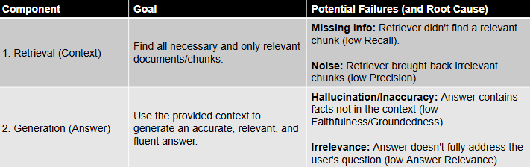

RAG Validation Workflow (Step-by-Step)
To effectively evaluate a RAG system, we follow a structured validation workflow.
The first and most critical step in this process is Data Preparation.
Data preparation is the foundation of RAG evaluation. By creating a diverse and high-quality test dataset with questions, expected contexts, and ground truth answers, we establish a reliable benchmark for measuring system performance

Step 1: Data Preparation — The Foundation
Validation is impossible without a well-prepared dataset.
A strong evaluation setup begins with creating a high-quality test set, often referred to as a “Golden Dataset”.

Creating a “Golden Test Dataset”.
A proper test dataset should include:
- Questions → User queries to test the system
- Expected Contexts → Relevant chunks that should ideally be retrieved
- Ground Truth Answers → Correct and complete responses
This dataset acts as a benchmark to measure system performance.

Golden Dataset is Important as:
- Provides a standard for comparison
- Helps in objective evaluation
- Enables consistent testing across iterations
- Acts as a reference for accuracy and relevance

Diversity is Key
A good evaluation dataset should not be limited to simple queries. It must include:
- Simple queries → Basic factual questions
- Complex queries → Multi-step reasoning questions
- Ambiguous queries → Requires interpretation
- Misspelled queries → Tests robustness
- Negative queries → Questions not answerable from the knowledge base
This ensures the system is tested under real-world scenarios.

Step 2: Evaluation Criteria — What Makes a RAG Response “Good”?

A. Retrieval Quality (Context)
Retrieval quality evaluates how effectively the system fetches relevant and useful context for a given query.
It ensures that the system provides the right context, which forms the foundation for generating accurate and meaningful responses.

What it Measures
- Relevance → Are the retrieved chunks related to the query?
- Coverage → Do they contain all necessary information?
- Precision → Are most retrieved chunks useful (low noise)?
If the retrieved context is incorrect or incomplete, the final answer will also be inaccurate, regardless of how powerful the LLM is.
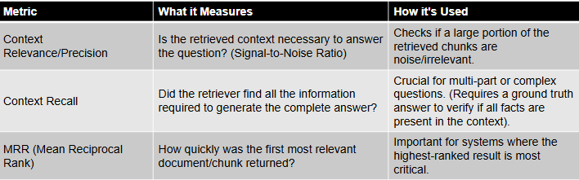

B. Generation Quality (Answer)
Generation quality evaluates how well the LLM produces the final answer using the retrieved context. It ensures that the final response is accurate, relevant, and grounded in context, making it reliable for users

What it Measures
- Accuracy → Is the answer factually correct?
- Faithfulness → Is the answer grounded in the retrieved context?
- Relevance → Does it directly answer the query?
- Completeness → Does it cover all important points?

Why it Matters
Even with correct context, a poor generation step can lead to hallucinations, incomplete answers, or misinterpretation.
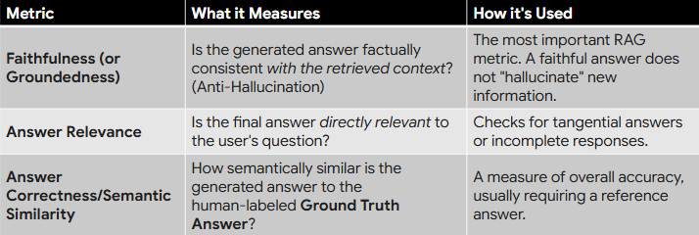

RAGAS Framework for RAG Evaluation
Evaluating all RAG metrics manually can be complex and time-consuming. To simplify this process, we use frameworks like RAGAS.
RAGAS simplifies the evaluation of RAG systems by automating metric calculation using an LLM-as-a-judge approach. It enables efficient, scalable, and standardized evaluation without relying heavily on manual effort.

What is RAGAS?
RAGAS (Retrieval-Augmented Generation Assessment Suite) is a popular open-source framework designed to automate the evaluation of RAG systems.
It computes key metrics without requiring extensive manual labeling.

How RAGAS Works
- Uses an LLM-as-a-judge approach
- Evaluates both:
  - Retrieval quality (context)
  - Generation quality (answer)
- Compares:
  - Query
  - Retrieved context
  - Generated response

Why Use RAGAS?
- Eliminates heavy manual evaluation effort
- Provides standardized metrics
- Scales easily for large datasets
- Speeds up development and optimization
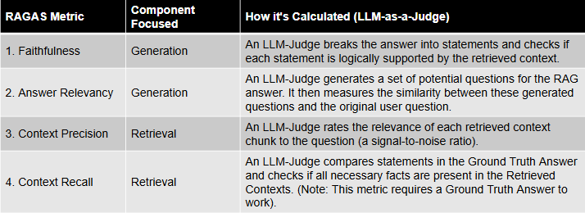

Example: Recall@K and Precision@K
This example shows that a system can retrieve all correct information (high recall) but still include irrelevant results (low precision), highlighting the need for optimization

User Query
“What is RAG?”

Ground Truth (Relevant Chunks)
- Chunk_2
- Chunk_4
- Total relevant chunks = 2

Retrieved Chunks (Top-5)
Rank | Chunk | Relevant
1 | Chunk_1 | ❌
2 | Chunk_2 | ✅
3 | Chunk_3 | ❌
4 | Chunk_4 | ✅
5 | Chunk_5 | ❌

Calculations

Recall@5
= Relevant retrieved / Total relevant
= 2 / 2 = 1.0 (100%)
All relevant chunks were retrieved

Precision@5
= Relevant retrieved / Total retrieved
= 2 / 5 = 0.4 (40%)
Some irrelevant chunks were also retrieved
Interpretation
- High Recall → Good coverage
- Low Precision → Noisy retrieval
Improvement needed: better filtering / reranking

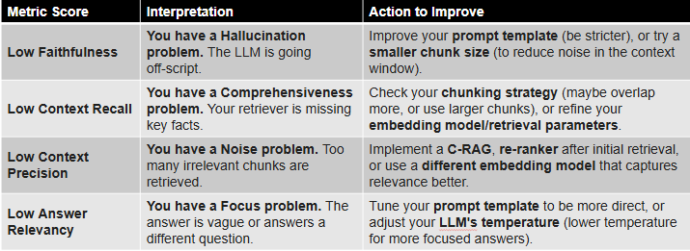

RAG Implementations

Corrective RAG (CRAG)
Corrective RAG (CRAG) is an advanced RAG implementation designed to improve retrieval quality when vector search returns noisy or irrelevant results.It enhances the standard RAG pipeline by introducing a correction mechanism that filters and refines retrieved chunks. This ensures that only high-quality, relevant context is passed to the LLM, resulting in more accurate and reliable responses.
It introduces an additional correction layer between retrieval and generation.

Why CRAG is Needed
In standard RAG:
- Vector search may return irrelevant or partially relevant chunks
- This leads to noisy context
- Resulting in incorrect or low-quality answers
CRAG solves this by cleaning and refining retrieved results before passing them to the LLM.

How CRAG Works
CRAG adds a corrector model that performs:
- Filtering → Removes irrelevant chunks
- Re-ranking → Prioritizes the most relevant chunks
- Routing (Optional) → Switches to:
  - Keyword search
  - Alternative retrievers

Workflow
- User query is received
- Vector retriever fetches Top-K chunks
- Corrector model evaluates retrieved chunks
- Irrelevant chunks are removed
- Relevant chunks are re-ranked
- Clean context is sent to the LLM
- LLM generates the final response

Self-Evaluating RAG (Self-RAG)
Self-Evaluating RAG (Self-RAG) is an advanced RAG approach where the LLM evaluates and corrects its own output using reflection and feedback loops. It enhances the standard pipeline by allowing the LLM to reflect on and refine its own responses. By incorporating self-correction loops, it ensures more accurate, consistent, and reliable outputs.
Unlike CRAG, which improves retrieval quality, Self-RAG focuses on improving answer quality after generation.

Why Self-RAG is Needed
Even with good retrieval:
- LLM may misinterpret context
- Generate incorrect or incomplete answers
- Introduce hallucinations
Self-RAG addresses this by enabling the model to review and refine its own response.

How Self-RAG Works
- User query is processed
- Relevant chunks are retrieved
- LLM generates an initial (draft) answer
- LLM performs a reflection step:
  - Compares answer with retrieved context
  - Checks for correctness and completeness
- If issues are found → self-correction is applied
- Final refined answer is returned

Hybrid RAG
Hybrid RAG combines semantic search (vector-based) and keyword search (e.g., BM25/ElasticSearch) to improve retrieval quality.
It enhances retrieval by combining vector-based semantic search with keyword-based exact matching. This ensures that the system captures both contextual meaning and precise information, leading to more accurate and reliable responses.
It leverages the strengths of both approaches:
- Vectors → capture meaning
- Keywords → capture exact matches

Why Hybrid RAG is Needed
Each retrieval method has limitations:
- Vector Search
  - Good at semantic understanding
  - May miss exact terms (numbers, clauses, keywords)
- Keyword Search (BM25)
  - Strong at exact matches
  - Misses semantic relationships
Hybrid RAG combines both to get more accurate and complete results.

How Hybrid RAG Works
- User query is received
- Two parallel searches are performed:
  - Semantic search (vector DB)
  - Keyword search (BM25/Elastic)
- Results from both are merged and ranked
- Final Top-K chunks are selected
- Sent to LLM for response generation

Example
User Query:
“What is the compensation limit under clause 11.2?”
Vector Search Output:
- Chunks related to compensation policies (semantic match)
Keyword Search Output:
- Exact clause 11.2 with specific numbers
Hybrid Result:
LLM receives:
- Semantically relevant context
- Exact clause with precise details

Key Benefits
- Improves retrieval accuracy
- Handles both meaning and exact queries
- Reduces missing critical information
- Especially useful for:
  - Legal documents
  - Policies
  - Technical specifications

